

**COMSATS University Islamabad (CUI)**

Software Requirement Specification  
(SRS DOCUMENT)

for

**<Cloud Laundrette>**  
Version 1.0

***By***

**Muhammad Anwar Sameen CIIT/SP18-BSE-076/ISB**

**Muhammad Usman Awan CIIT/SP18-BSE-086/ISB**

***Supervisor***  
**Mam Bushra Naz**

*Bachelor of Science in Software Engineering (2020)*

Revision History

|  |  |  |  |
| --- | --- | --- | --- |
| **Name** | **Date** | **Reason for Changes** | **Version** |
|  |  |  |  |
|  |  |  |  |
|  |  |  |  |
|  |  |  |  |
|  |  |  |  |
|  |  |  |  |

Application Evaluation History

|  |  |
| --- | --- |
| **Comments (by committee)**  **\*include the ones given at scope time both in doc and presentation** | **Action Taken** |
|  |  |
|  |  |
|  |  |
|  |  |
|  |  |

Supervised by

<Supervisor’s Name>

Signature______________

**Table of Contents**

1. Introduction i

1.1 Purpose i

1.2 Scope i

2. Overall Description i

2.1 Product Perspective ii

2.2 Operating Environment ii

2.3 Design and Implementation Constraints: ii

3. Requirement Identifying Technique iii

3.1 Use Case Diagram iii

3.2 Use Case Description vii

3.2.1 UC-1: LogIn vii

3.2.2 UC-3: SignUp ix

3.2.3 UC-4: View Profile x

3.2.4 UC-5: Profile Setting xi

3.2.5 UC-6: Notifications xii

3.2.6 UC-9: Check Launderette Reviews xv

3.2.7 UC-11: Find Launderette xvii

3.2.8 UC-12: Book Launderette xviii

3.2.9 UC-13: Payment Method xx

3.2.10 UC-14: Admin Dashboard xxi

3.2.11 UC-17: Launderer Dashboard xxiv

3.2.12 UC-20: LogOut xxviii

4. Functional Requirements xxix

4.1 FR-1: View Profile xxix

4.2 FR-2: Block/Unblock Client xxix

4.3 FR-3: Complaints xxx

4.4 FR-4: Launderer List xxx

4.5 FR-5: Launderer Details xxxi

4.6 FR-6: Create Account xxxi

4.7 FR-7: Select Service xxxi

4.8 FR-8: Launderettes Profile xxxii

4.9 FR-9: Find Launderer. xxxii

4.10 FR-10: Client Profile xxxiii

4.11 FR-11: Booking xxxiii

4.12 FR-12: Launderer Dashboard. xxxiv

4.13 FR-13: Client Notification xxxiv

4.14 FR-14: Feedbackand Review xxxv

4.15 FR-15: Payment xxxv

4.16 FR-16: Provide Services xxxvi

4.17 FR-17: Pick-up and Delivery xxxvi

4.18 FR-18: Communication xxxvii

4.19 FR-19: Accept/Decline xxxvii

4.20 FR-20: Order Requests xxxvii

4.21 FR-21: Order request list xxxviii

4.22 FR-22: View Order Details xxxviii

4.23 FR-23: Accept Order xxxix

4.24 FR-24: Reject Order xxxix

4.25 FR-25: Find Laundrette xl

4.26 FR-26: View Order Details xl

4.27 FR-27: Laundrette List xli

4.28 FR-28: Sort Laundrettes xli

4.29 FR-29: Sort launderettes by location xlii

4.30 FR-30: Sort launderettes by Rating xlii

4.31 FR-31: Sort launderettes by Price xliii

4.32 FR-32: Book launderette xliii

4.33 FR-33: Select Services xliii

4.34 FR-34: Booking details xliv

4.35 FR-35: Order history xliv

4.36 FR-36: Laundrette Reviews xlv

4.37 FR-37: Ongoing orders xlv

4.38 FR-38: Add service xlvi

4.39 FR-39: Delete Service xlvi

4.40 FR-40: Performance Reports xlvii

4.41 FR-41: Sales Report xlvii

4.42 FR-42: Review Report xlvii

5.Non-Functional Requirements xlviii

6. External Interface Requirements xlviii

4.43 User Interfaces xlix

4.44 Software Interfaces xlix

4.45 Hardware Interfaces: l

4.46 Communication Interfaces: l

5. Project Gantt Chart l

6. References li

7. Plagiarism Report li

# 

# Introduction

People are often so busy in their daily life routine that they don’t have enough time to get their laundry done as it is time so much time consuming. So they want to get their laundry done in an affordable and convenient way and also with no wastage of time. That is where the need of automation arises to provide the people with such laundry services. A platform where people can get their laundry picked-up from their doorsteps and delivered at their doorsteps. All the services related to the laundry such as washing, iron and dry cleaning shall be provided. Some people are too careful about the clothes and don’t want them damaged so they are looking for professionals who can get all these services done with their expertise. This platform will solve all their problems related to the laundry giving them more leisure or work time

## Purpose

The fnal outcome of this project is an Online Laundry system where people that are to busy in their daily routine life can get their laundry done in a more convenient and affordable way. So their time is saved and can focus on more important things. Previous system had faults and shortages. We are developing a system free of those a faults and shortages. Some systems had a very unfriendly user interface, missing chat option, limited to a specific area, and by hand payment a delivery no online payment, no review and feedback feature. Some systems had only web application while some had only android applications. So we decided to develop a system that will overcome a these shortages.

## Scope

An interactive platform for an online laundry cleaning system providing people with services such as washing, ironing and dry cleaning. This system has three main parts that is the client, Launderer and the admin that manages both the client and launderer. We have studied some systems that were either for android user or web users so we will be developing both web and android application and services will be provided. Client can place their appointment of their laundry pick-up and then delivered at their doorstep. Some people are too busy and sometimes they need their laundry to be done urgently so this service can also be provided.

# Overall Description

This section presents the overall description of the targeted project.

## Product Perspective

Many system like this are already available and after using and analyzing those systems, we observed various kind of faults and shortages and in order to overcome those shortages we had develop a better replacement for those systems that will cover all those shortages.

The System will have to user that is the client and launderer. The interaction between the both will happen through this application. The interaction can occur through the online chat system and through calls.

## Operating Environment

The system will be operating on both the android with android versions from 7.0 to 10.0 and on Windows, macOS and Linux. The Web browser on which the application will are Google chrome(version 60+), Firefox(version 60+),Internet Explorer(version 7+) and Opera(version 50+).

## Design and Implementation Constraints:

CO-1: PostgreSQL will be used as relational database.

CO-2: PostQuel will be used as database query language.

CO-3: Amazon RDS will be used to host our relational database.

CO-4: Heroku will be used as VPS hosting platform.

CO-5: Python will be used as programing language for website.

CO-6: Django will be used as backend framework for website.

CO-7: Django Rest Framework will be used to write REST APIs.

CO-8: PayPal Rest will be used as payment API.

CO-9: Dart will be used as programming language for mobile app.

CO-10: Flutter framework will be used for mobile app development.

CO-11: Google map api will be used for maps.

# Requirement Identifying Technique

## Use Case Diagram

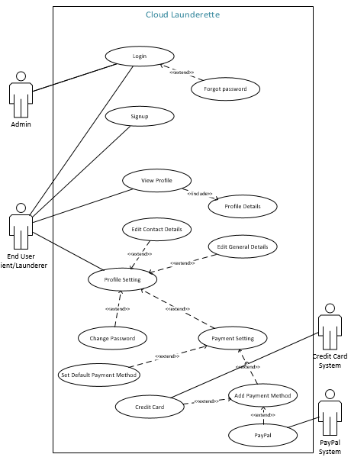

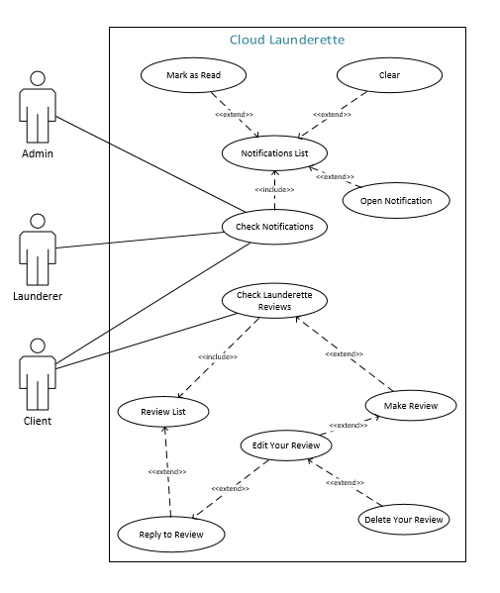

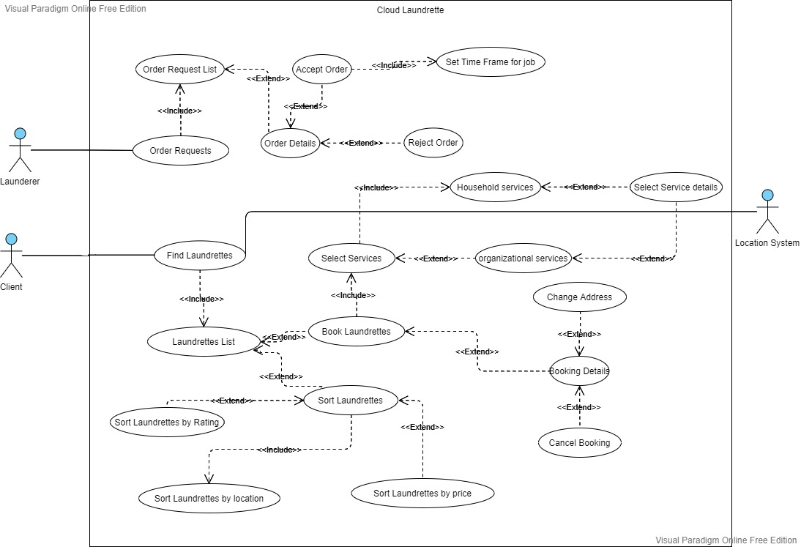

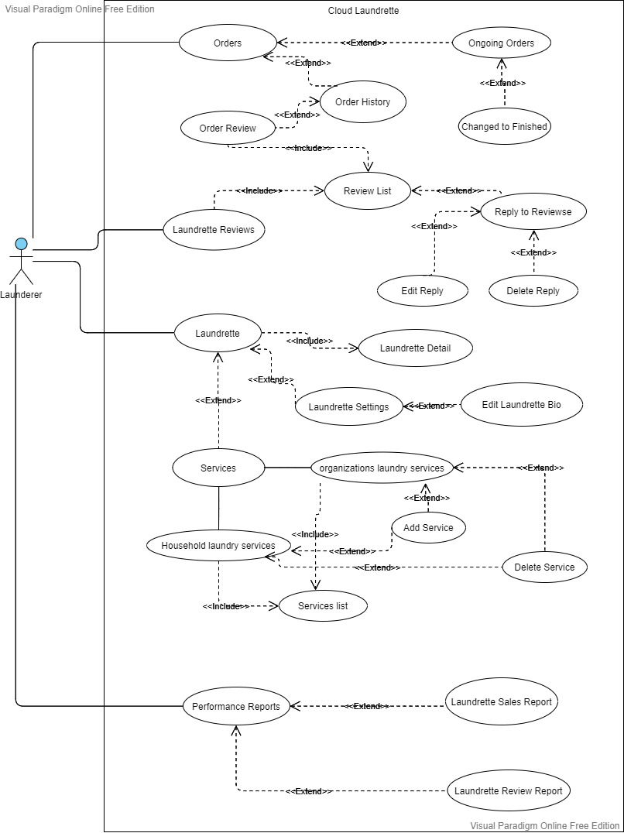

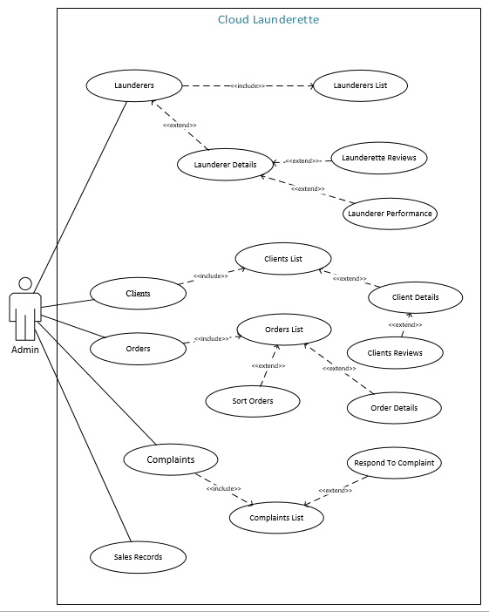

## Use Case Description

### UC-1: LogIn

|  |  |
| --- | --- |
| **Use Case ID:** | UC-1 |
|  |  |
| **Use Case Name:** | LogIn |
| **Actors:** | |  |  | | --- | --- | | Primary Actor: | Client, Launderer,Admin | |
| **Description:** | In order to access all the functionality of the Cloud Launderette user will have to login so they can use the system. |
| **Trigger:** | User clicks on login option |
| **Preconditions:** | PRE-1. User has registered their account. |
| **Postconditions:** | POST-1. User gets redirected to their home page after successful login. |
| **Normal Flow:** | 1. User enters their username/email.  2. User enters their password.  3. User presses login button.  4. Home screen is displayed to user. |
| **Alternative Flows:** | 1. User selects register account. |
| **Exceptions:** | 1. User enters wrong username/email.  2. User enters wrong password.  3. User is not registered. |
| **Business Rules** | BR-1: User must have internet connection. |
| **Assumptions:** | N/A |

#### UC-2: Forgot Password

|  |  |
| --- | --- |
| **Use Case ID:** | UC-2 |
|  |  |
| **Use Case Name:** | Forgot Password |
| **Actors:** | |  |  | | --- | --- | | Primary Actor: | Client, Launderer,Admin | |
| **Description:** | If user has forgotten the password the can use this use case to retrieve that password |
| **Trigger:** | User clicks on forgot password option |
| **Preconditions:** | PRE-1. User has registered their account.  PRE-2. User must be in UC-1 already. |
| **Postconditions:** | POST-1. User gets redirected to their home page after successful login. |
| **Normal Flow:** | 1. User enters their username/email.  2. A valid account relating to that username/email is shown.  3. User selects that account.  4. Code verification is sent to the relevant email.  5. User enters the verification code.  6. User presses enter button.  7. User is show new password interface.  8. User creates new password. |
| **Alternative Flows:** | 1. User enters invalid username/email. 2. No account found message is shown to the user. |
| **Exceptions:** | 1. User enters nothing in username/email field. |
| **Business Rules** | BR-1: User must have internet connection. |
| **Assumptions:** | N/A |

### UC-3: SignUp

|  |  |
| --- | --- |
| **Use Case ID:** | UC-3 |
| **Use Case Name:** | SignUp |
| **Actors:** | |  |  |  | | --- | --- | --- | | Primary Actor: | Client, Launderer,Admin |  | |
| **Description:** | User can create account if they don’t have already to use to the system |
| **Trigger:** | User indicates that he/she wants to use the system. |
| **Postconditions:** | POST-1. User account gets created.  POST-2. User gets automatically logged in. |
| **Normal Flow:** | 1. User enters their information.  2. User specify payment method.  3. User presses create account button.  3. User account gets created.  5. Home screen is displayed to user. |
| **Exceptions:** | 1. User enters invalid information.  . |
| **Business Rules** | BR-1: User must have stable internet connection. |
| **Assumptions:** | N/A |

### UC-4: View Profile

|  |  |
| --- | --- |
| **Use Case ID:** | UC-4 |
| **Use Case Name:** | View Profile |
| **Actors:** | |  |  |  | | --- | --- | --- | | Primary Actor: | Client, Launderer |  | |
| **Description:** | User wants to checks his profile to see how their bio looks and their details on that have been recorded on the system. |
| **Trigger:** | User click on View Profile Option. |
| **Preconditions:** | PRE-1. User has registered their account.  PRE-2. User is logged in.  PRE-3. User has internet connection. |
| **Postconditions:** | POST-1. User gets redirected to their or others profile page. |
| **Normal Flow:** | 1. User selects view profile option.  2. Relevant profile detail is show to the user. |
| **Alternative Flows:** | N/A |
| **Exceptions:** | N/A |
| **Business Rules** | BR-1: User must have stable internet connection.  BR-2: User must be logged in. |
| **Assumptions:** | N/A |

### UC-5: Profile Setting

|  |  |
| --- | --- |
| **Use Case ID:** | UC-5 |
| **Use Case Name:** | Profile Setting |
| **Actors:** | |  |  |  | | --- | --- | --- | | Primary Actor: | Client, Launderer, |  | |
| **Description:** | User can change their profile settings like changing the general information, contact information, password and can modify their payment settings. |
| **Trigger:** | User wants to change his profile information. |
| **Preconditions:** | PRE-1. User has registered their account.  PRE-2. User is logged in.  PRE-3. User has internet connection. |
| **Postconditions:** | POST-1. Success diaglog box is shown.  POST-2. User gets redirected to UC-4. |
| **Normal Flow:** | 1. User select the information he wants.  2. User modify the information he wants to change.  3. User presses save button.  4. User is redirected to CL-3. |
| **Alternative Flows:**  **[Alternative Flow 1 – Not in Network]** | 1. After the step 2 of normal flow, user clicks cancel. 2. Confirmation dialogue box appears. 3. User confirms it. 4. The information is not modified. 5. User gets redirected to CL-3 |
| **Exceptions:** | 1. User enters invalid information. 2. User doesn’t have a payment account. |
| **Business Rules** | BR-1: User must have stable internet connection. |
| **Assumptions:** | N/A |

### UC-6: Notifications

|  |  |
| --- | --- |
| **Use Case ID:** | UC-6 |
| **Use Case Name:** | Notifications |
| **Actors:** | |  |  | | --- | --- | | Primary Actor: | Client, Launderer,  Admin | |
| **Description:** | In notifications user can open their notification to check updates, they can mark the notification/notifications as read or clear them. |
| **Trigger:** | User wants to check any updates related to him or related to the system. |
| **Preconditions:** | PRE-1. User has registered their account.  PRE-2. User is logged in.  PRE-3. User has internet connection. |
| **Postconditions:** | POST-1. User gets redirected to specified page of the notification. |
| **Normal Flow:** | 1. User selects open notifications.  2. User reads the notifications  3. User can check a specific notification. |
| **Alternative Flows:** | 1. After step 2 of Normal Flow, user opens up a notification. 2. User is redirected to the related page. |
| **Exceptions:** | 1. User selects a notification whom reference page has been deleted or is unaccessible. |
| **Business Rules** | BR-1: User must have stable internet connection.  BR-2 Notification must be up to date with system. |
| **Assumptions:** | N/A |

#### UC-7: Mark As Read

|  |  |
| --- | --- |
| **Use Case ID:** | UC-7 |
| **Use Case Name:** | Mark As Read |
| **Actors:** | |  |  | | --- | --- | | Primary Actor: | Client, Launderer,  Admin | |
| **Description:** | When user wants to check single notification after reading/checking mark as read. User can also mark multiple notifications. |
| **Trigger:** | User selects notification and clicks on mark as read. |
| **Preconditions:** | PRE-1. User has registered their account.  PRE-2. User is logged in.  PRE-3. User is in UC-6 |
| **Postconditions:** | POST-1. Notifications get updated |
| **Normal Flow:** | 1. User selects open notifications.  2. User reads the notifications  3. User can check a specific/multiple notification as read. |
| **Alternative Flows:** | N/A |
| **Exceptions:** | 1. Notification has already been read. |
| **Business Rules** | BR-1: User must have stable internet connection.  BR-2: Notification must be up to date with system. |
| **Assumptions:** | N/A |

#### UC-8: Clear Notifications

|  |  |
| --- | --- |
| **Use Case ID:** | UC-8 |
| **Use Case Name:** | Clear Notifications |
| **Actors:** | |  |  | | --- | --- | | Primary Actor: | Client, Launderer,  Admin | |
| **Description:** | When user wants to clear all the or certain notification. |
| **Trigger:** | User selects notification and clicks clear. |
| **Preconditions:** | PRE-1. User has registered their account.  PRE-2. User is logged in.  PRE-3. User is in UC-6 |
| **Postconditions:** | POST-1. Notifications get updated |
| **Normal Flow:** | 1. User selects open notifications.  2. User clicks on clear.  3. User can clear a specific/multiple notification. |
| **Alternative Flows:** | N/A |
| **Exceptions:** | 1. Notification has already been read. |
| **Business Rules** | BR-1: User must have stable internet connection.  BR-2: Notification must be up to date with system. |
| **Assumptions:** | N/A |

### UC-9: Check Launderette Reviews

|  |  |
| --- | --- |
| **Use Case ID:** | UC-9 |
| **Use Case Name:** | Check Launderette Reviews |
| **Actors:** | |  |  | | --- | --- | | Primary Actor: | Client | |
| **Description:** | When client want to check reviews of a specific launderette. |
| **Trigger:** | Client clicks on Check Launderette Review option. |
| **Preconditions:** | PRE-1. User has registered their account.  PRE-2. User is logged in.  PRE-3. User has internet connection. |
| **Normal Flow:** | 1. Client opens up the Launderette.  2. Client checks the reviews.  3. List of reviews of specific Launderette is shown. |
| **Alternative Flows:** | N/A |
| **Exceptions:** | 1. Client is not logged in.  2. Client has no internet connection.  2. User is not registered. |
| **Business Rules** | N/A |
| **Assumptions:** | N/A |

#### UC-10: Make Review

|  |  |
| --- | --- |
| **Use Case ID:** | UC-10 |
| **Use Case Name:** | Make Reviews |
| **Actors:** | |  |  | | --- | --- | | Primary Actor: | Client | |
| **Description:** | When client wants to give his feedback of recent interaction with specific launderette. Client can edit or delete this review. |
| **Trigger:** | Client clicks on Make Review option. |
| **Preconditions:** | PRE-1. User has registered their account.  PRE-2. User is logged in.  PRE-3. User has internet connection. |
| **Normal Flow:** | 1. Client opens up the Launderette.  2. Client checks the reviews.  3. Client makes a new review. |
| **Alternative Flows:** | N/A |
| **Exceptions:** | 1. Client review is too big. 2. Client review is empty. |
| **Business Rules** | BR-1: Client must be inside UC-9. |
| **Assumptions:** | N/A |

### UC-11: Find Launderette

|  |  |
| --- | --- |
| **Use Case ID:** | UC-11 |
| **Use Case Name:** | Find Launderer |
| **Actors:** | |  |  |  |  | | --- | --- | --- | --- | | Primary Actor: | Client | Secondary Actors: | Location System | |
| **Description:** | For finding a launderer quickly based on location and furthermore price and rating who can provide laundry service for you. |
| **Trigger:** | Clients wants to book a launderette for their laundry work. |
| **Preconditions:** | PRE-1. Client has registered their account.  PRE-2. Client is logged in.  PRE-3. Client has internet connection.  PRE-4. Client has location turned on. |
| **Postconditions:** | POST-1. Clients sends laundry order to Launderer.  POST-2. Launderer either accepts or rejects the order. |
| **Normal Flow:** | 1. Client choses find launderer. 2. Client is show of list of launderettes close to them. 3. Client selects launderettes based on the price/rating/location. 4. Client selects the services they want to get. 5. Client order is sent to that launderette in UC-8. |
| **Alternative Flows:** | 1. Client cancels the order request. 2. Order request is removed the launderer portal. 3. Order notification is removed from launderer portal. |
| **Exceptions:** | 1. Client does not have location turned on. 2. Client order request doesn’t get sent. 3. Launderer doesn’t receive order request. |
| **Business Rules** | BR-1: Client can access this use case.  BR-2: Client must have location turned on.  BR-3: Client should be logged in.  BR-4: If location is turned off then last know location will be used as address. |
| **Assumptions:** | N/A |

### UC-12: Book Launderette

|  |  |
| --- | --- |
| **Use Case ID:** | UC-12 |
| **Use Case Name:** | Book Launderer |
| **Actors:** | |  |  |  |  | | --- | --- | --- | --- | | Primary Actor: | Launderer | Secondary Actors: | Location System | |
| **Description:** | All the order request will be received in this use case and launderer will be able to accept these request or reject them. If launderer accept theses request he can add time frame for the completion of order and and will quote price for the work. |
| **Trigger:** | Launderer wants to check for order request to work with. |
| **Preconditions:** | PRE-1. Launderer has registered their account.  PRE-2. Launderer is logged in.  PRE-3. Launderer has internet connection.  PRE-4. Launderer has location turned on. |
| **Postconditions:** | POST-1. Order approvel notification is sent to client.  POST-2. Launderer picks up the clothes. |
| **Normal Flow:** | 1. Launderer opens Requests. 2. Launderer is shown request based on time. 3. Launderer accepts a specific request. 4. Launderer sets the time frame for the job. 5. Launderer set price quota for the client. |
| **Alternative Flows:** | 1. Launderer checks the requests. 2. Launderer is busy so they reject the request. |
| **Exceptions:** | 1. Launderer payment account is expired. 2. Launderer location is turned off. 3. Launderer internet connection gets interrupted. 4. Launderer login is expired. |
| **Business Rules** | 1. BR-1: Launderer must be logged in. 2. BR-2: Launderer payment account should be active. 3. BR-3: Launderer should have valid internet connection. |
| **Assumptions:** | N/A |

### UC-13: Payment Method

|  |  |
| --- | --- |
| **Use Case ID:** | UC-13 |
| **Use Case Name:** | Payment Method |
| **Actors:** | |  |  |  | | --- | --- | --- | | Primary Actor: | Client, Launderer | | | Secondary Actors: | | PayPal System, Credit Card System | | |
| **Description:** | In order to get service clients needs to pay and launderer can use payment method to get the payments by clients. |
| **Trigger:** | Client wants to pay through paypal.  Launderer wants to get payment through paypal. |
| **Preconditions:** | PRE-1. User has registered their account.  PRE-2. User is logged in.  PRE-3. User has internet connection.  PRE-4. User has PayPal account. |
| **Postconditions:** | POST-1. Payment method should get updated. |
| **Normal Flow:** | 1. User selects payment method.  2. User selects payment through paypal account.  3. User enters paypal account information.  4. User saves and updates the payment method. |
| **Alternative Flows:**  **[Alternative Flow 1 – Not in Network]** | 1. User selects payment method.  2. User selects payment through physical cash.  3. User saves and updates the payment method. |
| **Exceptions:** | 1. User specifies invalid information.  2. PayPal api error. |
| **Business Rules** | 1. BR-1: Payment account must be valid. 2. BR-2: Payment account should be active. |
| **Assumptions:** | N/A |

### UC-14: Admin Dashboard

|  |  |
| --- | --- |
| **Use Case ID:** | UC-14 |
| **Use Case Name:** | Admin Dashboard |
| **Actors:** | |  |  | | --- | --- | | Primary Actor: | Admin | |
| **Description:** | After the admin has logged in, the admin dashboard will appear. The main elements that will be appear are Launderers, Clients, Complaints, Sales Records and logout. |
| **Trigger:** | The admin wants to use the system. |
| **Preconditions:** | 1. The admin has registered his account. 2. The admin has logged in into the system. |
| **Postconditions:** | N/A |
| **Normal Flow:** | 1. The admin logs in. 2. The admin can clicks on the Launderer. 3. The launderer windows appear displaying it’s information. |
| **Alternative Flows:**  **[Alternative Flow 1 – Not in Network]** | 1. The admin logs in. 2. The admin can clicks on the Launderer. 3. The launderer windows appear displaying it’s information. |
| **Exceptions:** | 1. User has already logged out. 2. Server is down. 3. Api error. |
| **Business Rules** | N/A |
| **Assumptions:** | N/A |

#### UC-15: Sales Report

|  |  |
| --- | --- |
| **Use Case ID:** | UC-15 |
| **Use Case Name:** | Sales Report |
| **Actors:** | |  |  | | --- | --- | | Primary Actor: | Admin | |
| **Description:** | Admin wants to check reports relating to sales. |
| **Trigger:** | Admin clicks on sales report. |
| **Preconditions:** | 1. The admin has logged in into the system. |
| **Postconditions:** | N/A |
| **Normal Flow:** | 1. The admin logs in. 2. The admin can clicks on the Sales Report. 3. Sales record based on current date is shown. 4. Admin can change this date to any previous date and sort on that. |
| **Alternative Flows:**  **[Alternative Flow 1 – Not in Network]** | N/A |
| **Exceptions:** | 1. Admin has already logged out. 2. Server is down. 3. Reports doesn’t exist. |
| **Business Rules** | N/A |
| **Assumptions:** | N/A |

#### UC-16: Complaints

|  |  |
| --- | --- |
| **Use Case ID:** | UC-16 |
| **Use Case Name:** | Complaints |
| **Actors:** | |  |  | | --- | --- | | Primary Actor: | Admin | |
| **Description:** | Admin can check list of complaints, can respond to complaint and change complaint status. |
| **Trigger:** | Admin clicks on Complaints. |
| **Preconditions:** | 1. The admin has logged in into the system. |
| **Postconditions:** | 1. Complaints List is shown. |
| **Normal Flow:** | 1. The admin logs in. 2. The admin can clicks on the Complaints. 3. List of Complaints is shown to admin. 4. Admin selects a complaint. 5. Admin responds to the complaint. 6. Admin changes the status of complaint. |
| **Alternative Flows:**  **[Alternative Flow 1 – Not in Network]** | N/A |
| **Exceptions:** | 1. Admin has already logged out. 2. Server is down. |
| **Business Rules** | BR-1: Complaints should get updated after admin responds to complaint.  BR-2: Complaints should get updated when admin changes the status of complaints. |
| **Assumptions:** | N/A |

### UC-17: Launderer Dashboard

|  |  |
| --- | --- |
| **Use Case ID:** | UC-15 |
| **Use Case Name:** | Launderer Dashboard |
| **Actors:** | |  |  | | --- | --- | | Primary Actor: | Launderer | |
| **Description:** | After the launderer has logged in, the launderer dashboard will appear. The main elements that will be appear are orders, laundrette, Reviews, performance reports and logout. |
| **Trigger:** | The launderer wants to use the system. |
| **Preconditions:** | 1. The launderer has registered his account. 2. The launderer has logged in into the system. |
| **Postconditions:** | N/A |
| **Normal Flow:** | 1. The launderer logs in. 2. The launderer can clicks on the order. 3. The Orders windows appear displaying it’s information. |
| **Alternative Flows:**  **[Alternative Flow 1 – Not in Network]** | 1. The launderer logs in. 2. The launderer clicks on the Review. 3. The Review window appear displaying the sales information. |
| **Exceptions:** | 1. User has already logged out. 2. Server is down. 3. Api error. |
| **Business Rules** | N/A |
| **Assumptions:** | N/A |

#### UC-18: Services

|  |  |
| --- | --- |
| **Use Case ID:** | UC-18 |
| **Use Case Name:** | Services |
| **Actors:** | |  |  | | --- | --- | | Primary Actor: | Launderer | |
| **Description:** | Launderer wants to see the services they provided in the launderette.  Launderer can modify these services, delete them and add new service. |
| **Trigger:** | The launderer clicks on Services |
| **Preconditions:** | 1. The launderer has registered his account. 2. The launderer has logged in into the system. |
| **Postconditions:** | Launderer gets redirected to services page |
| **Normal Flow:** | 1. The launderer logs in. 2. The launderer can clicks on the Launderette. 3. Launderer clicks on services. 4. List of services is displayed. 5. Launderer adds a new services. 6. Launderer specify the price of the service. |
| **Alternative Flows:**  **[Alternative Flow 1 – Not in Network]** | 1. After step 4 of normal flow. Launderer deletes a service. 2. Updated services are shown. |
| **Exceptions:** | 1. User has already logged out. 2. Server is down. 3. Api error. |
| **Business Rules** | N/A |
| **Assumptions:** | N/A |

#### UC-19: Orders

|  |  |
| --- | --- |
| **Use Case ID:** | UC-19 |
| **Use Case Name:** | Orders |
| **Actors:** | |  |  | | --- | --- | | Primary Actor: | Launderer | |
| **Description:** | Launderer wants to see the orders they finished which are ongoing or declined. Launderer can check details and payment of the order and can change the status of order. |
| **Trigger:** | The launderer clicks on orders. |
| **Preconditions:** | 1. The launderer has registered his account. 2. The launderer has logged in into the system. |
| **Postconditions:** | N/A |
| **Normal Flow:** | 1. The launderer logs in. 2. The launderer can clicks on the Launderette. 3. Launderer clicks on orders. 4. List of orders is displayed. 5. Launderer changes the state of order. |
| **Alternative Flows:**  **[Alternative Flow 1 – Not in Network]** | 1. After step 4 of normal flow. Launderer clicks on order detail. 2. Order details are displayed. |
| **Exceptions:** | * User has already logged out. * Server is down. * Api error. |
| **Business Rules** | N/A |
| **Assumptions:** | N/A |

### UC-20: LogOut

|  |  |
| --- | --- |
| **Use Case ID:** | UC-16 |
| **Use Case Name:** | LogOut |
| **Actors:** | |  |  |  | | --- | --- | --- | | Primary Actor: | Client, Launderer,Admin |  | |
| **Description:** | When the actors are finished on working on the job they logged in for. They can click on log out to terminate the session. |
| **Trigger:** | User has finished up using the application. |
| **Preconditions:** | User has logged in and and he is done using the application |
| **Postconditions:** | The user is logged out and redirected to the login page. |
| **Normal Flow:** | 1. User is done using the application  2.The user clicks on the logout.  3. The user is redirected to the login page. |
| **Alternative Flows:**  **[Alternative Flow 1 – Not in Network]** | None |
| **Exceptions:** | None |
| **Business Rules** | N/A |
| **Assumptions:** | So that no one uses the system with the user credentials other than him. |

# Functional Requirements

## FR-1: View Profile

|  |  |
| --- | --- |
| **Identifier** | FR-1 |
| **Title** | View Profile. |
| **Requirement** | If the client or Laundere are registered in the system then the admin can view their profiles.  The admin can view all the profiles which either be a Launderer or a client registered in the system. |
| **Source** | Admin class. |
| **Rationale** | The admin can view everyone that is registered to the system using the system and utilizing the services. |
| **Business Rule (if required)** | None |
| **Dependencies** | None |
| **Priority** | Medium |

## FR-2: Block/Unblock Client

|  |  |
| --- | --- |
| **Identifier** | FR-2 |
| **Title** | Block/unblock Client. |
| **Requirement** | If the client has some pending payment issues or other issues then the admin can block the client and after the issues are cleared then the admin can unblock him/her. |
| **Source** | Admin class. |
| **Rationale** | The admin can block/unblock client if there is and issue and can also unblock him. |
| **Business Rule (if required)** | None |
| **Dependencies** | None |
| **Priority** | High |

## FR-3: Complaints

|  |  |
| --- | --- |
| **Identifier** | FR-3 |
| **Title** | Complaints |
| **Requirement** | If a user has registered a complaint then the admin will be the one to resolve the all the complaints regarding the system or the services.  The client can also see the status of the complaint. |
| **Source** | Admin class. |
| **Rationale** | Problem in the system or services can occur os the admin must able to remove or resolve all those problems. |
| **Business Rule (if required)** | None |
| **Dependencies** | None |
| **Priority** | High |

## FR-4: Launderer List

|  |  |
| --- | --- |
| **Identifier** | FR-4 |
| **Title** | Launderer List |
| **Requirement** | The launderer list will contain all the launderers that are registered in the system and their respected information. |
| **Source** | Admin class. |
| **Rationale** | A list of all the launderers that have registered themselves in the system so that the admin can view it. |
| **Business Rule (if required)** | None |
| **Dependencies** | None |
| **Priority** | High |

## FR-5: Launderer Details

|  |  |
| --- | --- |
| **Identifier** | FR-5 |
| **Title** | Launderer Details |
| **Requirement** | The launderer details contains all the information regarding a particular launderer and the information can also include the review and performance reports. |
| **Source** | Admin class. |
| **Rationale** | The admin can view a specific launderer and see that launderer details. |
| **Business Rule (if required)** | None |
| **Dependencies** | None |
| **Priority** | High |

## FR-6: Create Account

|  |  |
| --- | --- |
| **Identifier** | FR-6 |
| **Title** | Create Account. |
| **Requirement** | If the client wants use the system he must have to create an account first.  Creating account is the first step and after that the user can avail all the services that he requires. |
| **Source** | Client class. |
| **Rationale** | The user/client cannot use the services until he had created account in the system. |
| **Business Rule (if required)** | None |
| **Dependencies** |  |
| **Priority** | High |

## FR-7: Select Service

|  |  |
| --- | --- |
| **Identifier** | FR-7 |
| **Title** | Select Service. |
| **Requirement** | After the users has registered himself onto the system then he can select from list of services that he wants such washing,ironing or dry cleaning. |
| **Source** | Client class. |
| **Rationale** | To use the available services he must have to select from a list of those services. |
| **Business Rule (if required)** | None |
| **Dependencies** | None |
| **Priority** | High |

## FR-8: Launderettes Profile

|  |  |
| --- | --- |
| **Identifier** | FR-8 |
| **Title** | Launderettes Profile |
| **Requirement** | If the user are unaware of the Launderette details then he can look into their profile and check details like services prices in price class to check if he can afford their services or not. |
| **Source** | Client class. |
| **Rationale** | To let the client know of the charges for the services so that he can apply knowing he can afford it or not. |
| **Business Rule (if required)** | None |
| **Dependencies** | None |
| **Priority** | Low |

## FR-9: Find Launderer.

|  |  |
| --- | --- |
| **Identifier** | FR-9 |
| **Title** | Find Launderer |
| **Requirement** | The find launderer will look for professionals who can get their laundry in the best way possible and the way they want.It will look for the launderer in that specific area and display them so that they can get their services done through them. |
| **Source** | Client class. |
| **Rationale** | As different areas will have different launderers, so the find launderer will find it and list launderers in that specific area. |
| **Business Rule (if required)** | None |
| **Dependencies** | None |
| **Priority** | Medium |

## FR-10: Client Profile

|  |  |
| --- | --- |
| **Identifier** | FR-10 |
| **Title** | Client Profile |
| **Requirement** | The profile requirement will contain all the personal details of a specific that the client provided during the creation of the account. These details can be changed when through the profile settings and updated.These details can be the user name,name, address etc. |
| **Source** | Client class. |
| **Rationale** | To contain the details of client so that they can be used and changed later,a profile FR is required. |
| **Business Rule (if required)** | None |
| **Dependencies** | None |
| **Priority** | High |

## FR-11: Booking

|  |  |
| --- | --- |
| **Identifier** | FR-12 |
| **Title** | Booking |
| **Requirement** | The Booking will enable the client to make the appointment for the pick-up of their laundry from their door-step. The booking will contain all the details that is address etc. |
| **Source** | Client class. |
| **Rationale** | For the client to set the appointment so that the laundry can be picked-up and delivered , a booking functional requirement is required. |
| **Business Rule (if required)** | None |
| **Dependencies** | None |
| **Priority** | High |

## FR-12: Launderer Dashboard.

|  |  |
| --- | --- |
| **Identifier** | FR-12 |
| **Title** | Launderer Dashboard |
| **Requirement** | The Launderer dashboard will contain both the services that are provided and the status of payment, orders. The Services are washing,ironing and dry cleaning etc and orders will contain will contain information about the laundry that is it done or not. It will also contains new offers provided. |
| **Source** | Client class. |
| **Rationale** | The home page meaning dashboard of the client will contain services and status and new offers functionality. |
| **Business Rule (if required)** | None |
| **Dependencies** | None |
| **Priority** | Medium |

## FR-13: Client Notification

|  |  |
| --- | --- |
| **Identifier** | FR-13 |
| **Title** | Client Notification. |
| **Requirement** | The notification requirement will give client the information like their laundry is done, their laundry is done and like their laundry is about to be delivered. |
| **Source** | Client class. |
| **Rationale** | To make the client updated regarding their laundry and new offers, a notification system is required |
| **Business Rule (if required)** | None |
| **Dependencies** | None |
| **Priority** | Medium |

## FR-14: Feedbackand Review

|  |  |
| --- | --- |
| **Identifier** | FR-14 |
| **Title** | Feedback and Review |
| **Requirement** | The feedback will provide the client with the opportunity to let the launderer know how their experience was and how the can improve it. |
| **Source** | Client class. |
| **Rationale** | To let the launderer improve their services, a feedback system is required so that the launderer knows about their shortages and can overcome |
| **Business Rule (if required)** | None |
| **Dependencies** | None |
| **Priority** | High |

## FR-15: Payment

|  |  |
| --- | --- |
| **Identifier** | FR-15 |
| **Title** | Payment |
| **Requirement** | The payment will contain all the payment history including all the payments that’s been paid, pending etc. |
| **Source** | Client class. |
| **Rationale** | The payment will contain all the payment history including all the payments that’s been paid, pending etc. |
| **Business Rule (if required)** | None |
| **Dependencies** | None |
| **Priority** | High |

## FR-16: Provide Services

|  |  |
| --- | --- |
| **Identifier** | FR-16 |
| **Title** | Provide Services. |
| **Requirement** | If the client requires any services then those services will be provided by the launderer. The Launderer will communicate with the client and then deliver the services. |
| **Source** | Launderer class. |
| **Rationale** | The Launderer will be the one managing all the services and client. He will the delieverer of the services. |
| **Business Rule (if required)** | None |
| **Dependencies** | None |
| **Priority** | High. |

## FR-17: Pick-up and Delivery

|  |  |
| --- | --- |
| **Identifier** | FR-17 |
| **Title** | Pick-up and Delivery |
| **Requirement** | When the client set’s up an appointment at a specific time then the launderer will be responsible for the pick-up of the laundry and after cleaning services done they are to be delivered to the destination. |
| **Source** | Launderer class. |
| **Rationale** | The Launderer will be the one managing the pick-up and delivery of the laundry. |
| **Business Rule (if required)** | None |
| **Dependencies** | None |
| **Priority** | Medium |

## FR-18: Communication

|  |  |
| --- | --- |
| **Identifier** | FR-18 |
| **Title** | Communication |
| **Requirement** | The Launderer will be managing the communication with the client.The Launderer will be responsible for getting the details from the client and in case of any query, he will be the one resolving that query. |
| **Source** | Launderer class. |
| **Rationale** | In case of any query or help, the launderer will be the one who resolves it. |
| **Business Rule (if required)** | None |
| **Dependencies** | None |
| **Priority** | High |

## FR-19: Accept/Decline

|  |  |
| --- | --- |
| **Identifier** | FR-20 |
| **Title** | Accept/Decline Client |
| **Requirement** | The Launderer can accept or decline a particular client based on the conditions. That is maybe the available appointment time is already fixed for another client or is from an area where we don’t provide these services. |
| **Source** | Launderer Class |
| **Rationale** | Launderer can accept or decline a particular client based on the conditions. That is maybe the available appointment time is already fixed for another client or is from an area where we don’t provide these services. |
| **Business Rule (if required)** | None |
| **Dependencies** | None |
| **Priority** | Medium |

## FR-20: Order Requests

|  |  |
| --- | --- |
| **Identifier** | FR-20 |
| **Title** | Order Requests |
| **Requirement** | The order requests will include all the order request sent by different clients to the launderer. It will includes all the order details. |
| **Source** | Launderer Class |
| **Rationale** | The Launderer can see all the order requests and all the details regarding those orders |
| **Business Rule (if required)** | None |
| **Dependencies** | None |
| **Priority** | Medium |

## FR-21: Order request list

|  |  |
| --- | --- |
| **Identifier** | FR-21 |
| **Title** | Order request list |
| **Requirement** | A list of all the order is to be displayed when the launderer clicks on the order requests and then he will have have the option of selecting order requests |
| **Source** | Launderer Class |
| **Rationale** | When the launderer clicks on the order request, a list of all the order requests will be displayed and then launderer can accordingly. |
| **Business Rule (if required)** | None |
| **Dependencies** | None |
| **Priority** | High |

## FR-22: View Order Details

|  |  |
| --- | --- |
| **Identifier** | FR-22 |
| **Title** | View Order Details |
| **Requirement** | The view order details will display all the details of a specific order. The details will include the appointment timing, client details and launderer can accept and reject it. |
| **Source** | Launderer Class |
| **Rationale** | All the details will be displayed related to a single order when a clients clicks on it. |
| **Business Rule (if required)** | None |
| **Dependencies** | None |
| **Priority** | High |

## FR-23: Accept Order

|  |  |
| --- | --- |
| **Identifier** | FR-23 |
| **Title** | Accept Order |
| **Requirement** | The accept order will accept the clients order and then the launderer will pick-up the laundry and will make a schedule to this particular laundry and will dropped off at the destination. |
| **Source** | Launderer Class |
| **Rationale** | The launderer will agree to the appointment set by the client and then the laundry will picked up and dropped after the laundry services being done. |
| **Business Rule (if required)** | None |
| **Dependencies** | None |
| **Priority** | Medium |

## FR-24: Reject Order

|  |  |
| --- | --- |
| **Identifier** | FR-24 |
| **Title** | Reject Order |
| **Requirement** | The order will be reject by the launderer because the laundry cannot be delivered at the appointed time. |
| **Source** | Launderer Class |
| **Rationale** | The launderer can reject the order request sent by a particular client. |
| **Business Rule (if required)** | None |
| **Dependencies** | None |
| **Priority** | Low |

## FR-25: Find Laundrette

|  |  |
| --- | --- |
| **Identifier** | FR-25 |
| **Title** | Find Laundrette |
| **Requirement** | The find launderette requirement will look for the launderette in the nearby location. The client can also search the launderettes like by price, ratings and location. The list of all the launderettes will be displayed. |
| **Source** | Client Class |
| **Rationale** | If the client requires services after registering to the system then he can search for the launderettes through different ways such as by location,price and ratings. |
| **Business Rule (if required)** | None |
| **Dependencies** | None |
| **Priority** | High |

## FR-26: View Order Details

|  |  |
| --- | --- |
| **Identifier** | FR-26 |
| **Title** | View Order Details |
| **Requirement** | The view order details will display all the details of a specific order. The details will include the appointment timing, client details and launderer can accept and reject it. |
| **Source** | Client Class |
| **Rationale** | All the details will be displayed related to a single order when a clients clicks on it. |
| **Business Rule (if required)** | None |
| **Dependencies** | None |
| **Priority** | High |

## FR-27: Laundrette List

|  |  |
| --- | --- |
| **Identifier** | FR-27 |
| **Title** | Laundrette List |
| **Requirement** | The launderette list will display all the launderette available and the client can select the suitable one. He can then send request to him. |
| **Source** | Client Class |
| **Rationale** | The launderette list will contain the all the launderettes and client can select from it. |
| **Business Rule (if required)** | None |
| **Dependencies** | None |
| **Priority** | High |

## FR-28: Sort Laundrettes

|  |  |
| --- | --- |
| **Identifier** | FR-28 |
| **Title** | Sort Laundrettes |
| **Requirement** | The sort launderette provides client with the choice of displaying launderettes through ratings, prices and by location. |
| **Source** | Client Class |
| **Rationale** | The launderettes can be sorted in three different ways. They are as follows:   * Sort by location. * Sort by Price. * Sort by Ratings. |
| **Business Rule (if required)** | None |
| **Dependencies** | None |
| **Priority** | Medium |

## FR-29: Sort launderettes by location

|  |  |
| --- | --- |
| **Identifier** | FR-29 |
| **Title** | Sort launderettes by location |
| **Requirement** | The sort by location will display all the launderettes that are close at the top and display the farther ones below them. |
| **Source** | Client Class |
| **Rationale** | To provide clients with the convenience of locating the launderettes that are near and farther, sort by locating is used. |
| **Business Rule (if required)** | None |
| **Dependencies** | None |
| **Priority** | Medium |

## FR-30: Sort launderettes by Rating

|  |  |
| --- | --- |
| **Identifier** | FR-30 |
| **Title** | Sort launderettes by Ratings |
| **Requirement** | This will sort the launderettes in the descending order with highleu rated at the top and then coming down to the low rated ones. |
| **Source** | Client Class |
| **Rationale** | Some clients are looking for the best laundry services, so they look for the ratings and selects the launderettes. |
| **Business Rule (if required)** | None |
| **Dependencies** | None |
| **Priority** | Medium |

## FR-31: Sort launderettes by Price

|  |  |
| --- | --- |
| **Identifier** | FR-31 |
| **Title** | Sort launderettes by Price |
| **Requirement** | This will sort the launderettes with the low price launderettes at the top and ascending down in increasing order. |
| **Source** | Client Class |
| **Rationale** | A launderettes will be displayed in ascending order with launderette having low rates at the top and increasing as going down the list of launderettes. |
| **Business Rule (if required)** | None |
| **Dependencies** | None |
| **Priority** | Medium |

## FR-32: Book launderette

|  |  |
| --- | --- |
| **Identifier** | FR-32 |
| **Title** | Book launderette |
| **Requirement** | The client will select a particular laundretted that is providing the desired services as required by the client. Then the client can select the services and enter the booking details. |
| **Source** | Client Class |
| **Rationale** | The book launderette will select the desired launderette and the details will be provided to the launderette and request will be sent to the launderette. |
| **Business Rule (if required)** | None |
| **Dependencies** | None |
| **Priority** | High |

## FR-33: Select Services

|  |  |
| --- | --- |
| **Identifier** | FR-33 |
| **Title** | Select Services |
| **Requirement** | The client will have to select the laundry services that he requires and provided by the launderette. These services can be washing,ironing and dry cleaning. |
| **Source** | Client Class |
| **Rationale** | The select service will allow the client to select the services that he requires provided by particular launderer. |
| **Business Rule (if required)** | None |
| **Dependencies** | None |
| **Priority** | Medium |

## FR-34: Booking details

|  |  |
| --- | --- |
| **Identifier** | FR-34 |
| **Title** | Booking details |
| **Requirement** | The client will have to enter the booking details that can be address and time of appointment. |
| **Source** | Client Class |
| **Rationale** | The client will provide the necessary details as required by the launderer. |
| **Business Rule (if required)** | None |
| **Dependencies** | None |
| **Priority** | Medium |

## FR-35: Order history

|  |  |
| --- | --- |
| **Identifier** | FR-35 |
| **Title** | Order history |
| **Requirement** | The order history will include the all the details of a particular order such as the date of booking, pick-up and delivery information etc. |
| **Source** | Launderer Class |
| **Rationale** | A launderer can see the the details of a particular and all the reviews that the launderer provided about it. |
| **Business Rule (if required)** | None |
| **Dependencies** | None |
| **Priority** | High |

## FR-36: Laundrette Reviews

|  |  |
| --- | --- |
| **Identifier** | FR-36 |
| **Title** | Laundrette Reviews |
| **Requirement** | It will provided the launderer about the clients opinion and the quality of the services that he provides and then he can improve the system keeping in mind the review. |
| **Source** | Launderer Class |
| **Rationale** | To collect the clients opinion about how he felt about the launderer a reviews systems is important. |
| **Business Rule (if required)** | None |
| **Dependencies** | None |
| **Priority** | High |

## FR-37: Ongoing orders

|  |  |
| --- | --- |
| **Identifier** | FR-37 |
| **Title** | Ongoing orders |
| **Requirement** | The Lauderer can view all the ongoing orders and check the status of those orders. |
| **Source** | Launderer Class |
| **Rationale** | To look into the status of the ongoing orders the launderer can view the ongoing orders. |
| **Business Rule (if required)** | None |
| **Dependencies** | None |
| **Priority** | Medium |

## FR-38: Add service

|  |  |
| --- | --- |
| **Identifier** | FR-38 |
| **Title** | Add service |
| **Requirement** | If the launderette want to provide more services to the clients then he can add more services and the clients can get those services |
| **Source** | Launderer Class |
| **Rationale** | Add service will add more services to the launderette profile and then the clients can achieve those services. |
| **Business Rule (if required)** | None |
| **Dependencies** | None |
| **Priority** | Medium |

## FR-39: Delete Service

|  |  |
| --- | --- |
| **Identifier** | FR-39 |
| **Title** | Delete Service |
| **Requirement** | If the launderer are no longer providing a particular services then he can deletes those services so that they are no longer showing up on the launderer profile. |
| **Source** | Launderer Class |
| **Rationale** | The launderer can delete a services if they are no providing it no more. |
| **Business Rule (if required)** | None |
| **Dependencies** | None |
| **Priority** | Medium |

## FR-40: Performance Reports

|  |  |
| --- | --- |
| **Identifier** | FR-40 |
| **Title** | Performance Reports |
| **Requirement** | The performance report will contain the launderet sales report and the launderette review report. |
| **Source** | Launderer Class |
| **Rationale** | If the launderer wants to know about their performance then can view the performance report. |
| **Business Rule (if required)** | None |
| **Dependencies** | None |
| **Priority** | Medium |

## FR-41: Sales Report

|  |  |
| --- | --- |
| **Identifier** | FR-41 |
| **Title** | Sales Report |
| **Requirement** | The sales report will contain all the launderet sales that all the orders that are completed uptill now. |
| **Source** | Launderer Class |
| **Rationale** | The launderer can check their sales report through the sales report. |
| **Business Rule (if required)** | None |
| **Dependencies** | None |
| **Priority** | Medium |

## FR-42: Review Report

|  |  |
| --- | --- |
| **Identifier** | FR-42 |
| **Title** | Review Report |
| **Requirement** | The review report will contain all the information regarding the services that a particular launderer provided and he can view it. |
| **Source** | Launderer Class |
| **Rationale** | The launderer can check how people see their services and how they can improve it by checking the review report. |
| **Business Rule (if required)** | None |
| **Dependencies** | None |
| **Priority** | High |

# 5.Non-Functional Requirements

1. Performance:
   * The response time of the system shall be made as low as possible.
   * Responses to view information shall take no longer than 5 seconds to appear on the screen.
2. Security Requirements
   * System will use secured database.
   * Password encryption shall be used.
   * System will have different types of users and every user has access constraints.
3. Compatibility:

* The system shall be able to support all android versions from 7 to 10.
* The web shall also be supporting all the latest versions of web browsers.

1. Usability:
   * The system shall be very friendly.
   * The system shall be easy to use.
2. Sacalbility:
   * The system shall be able to accommodate max number of users without any fault such as system slowing down etc.

# External Interface Requirements

This section provides details for all the interfaces that will be developed throughout this whole project.

They are as follows:

## User Interfaces

* Login Page Interface:

The Login interface will have two main components that is the user name and password. There will be a registration button located in the top right corner and a forgot password right below the loginbutton. A login button will be below password field.

* Registration Interface:

The register interface will include the name, email ,phone number, user name, password and address. After clicking on the registration button, a window will appear and all the fields will be displayed vertically in a column and at the end a register button will be there.

* Dashboard Interface:

The Dashboard interface will contain two main Componen that is the services and and the status to check the status of the orders, client and the Payment. The services will be inside a button that will lead to pages where all the services will be listed. The client will contain all the client, the orders will contains orders that are pending, complete and unfinished.

* Orders Page:

The orders will contains orders that are pending, complete and upcoming.

The upcoming ones are those whose orders been placed but the laundry is not picked-up.

* Payment:

The Payment will contain all the orders which payment been done.

* Profile Interface

The profile interface will include all the user details listed in column There is an edit button at the bottom and when clicked all the details will appear in an editable form and can be changed and after clicking on the update button all the details will get updated.

* Services Interface

The services page will include all the services that are being provided. These services are washing, ironing and dry cleaning. These services can be clicked on and a page will appear asking details about the laundry.

* Contact Us Interface

The contact us interface will include all the details that through which the client can contact the launderer. The details can be phone number, email whattsapp contact etc.

## Software Interfaces

This application will use different type of software interfaces for web and android based functionality. For the web, Html,CSS,Javascript, Django,Python and Bootstrap. For the android, the interfaces that will be used are Flutter and dart.

## Hardware Interfaces:

The hardware interface for the android application will be any android device that can connect to the internet and have an android version 7+. The web application will be any hardware device that could connect to the internet as the web requires internet connection.

## Communication Interfaces:

The communication interface required here is the HTTP that will help in communicating with the clients. The AWS shall also be used as communication interface.

# Project Gantt Chart

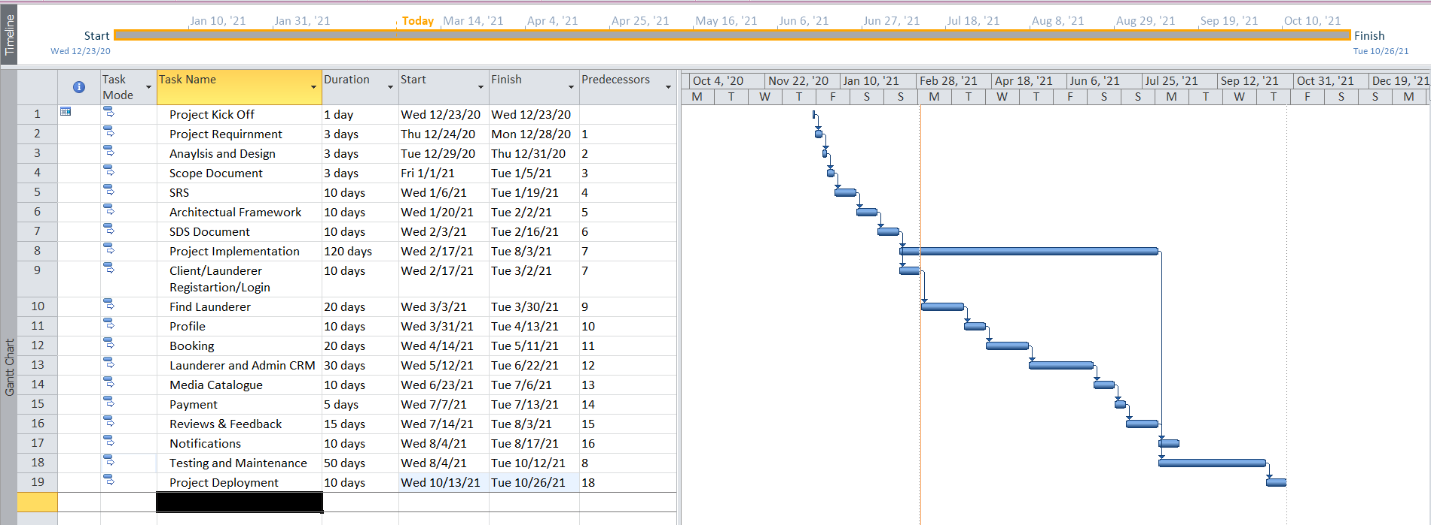

Figure 1: Gant Chart of the Targeted Project.

# References

1. https://elaundry.pk/
2. https://dhobionline.pk/
3. https://www.laundryxpress.pk/
4. https://sastadhobi.com/
5. https://washnclean.pk/

# Plagiarism Report

